Lab 4
Web programming

Name : umar ahad uddin ahmed usmani
Sap : 60199

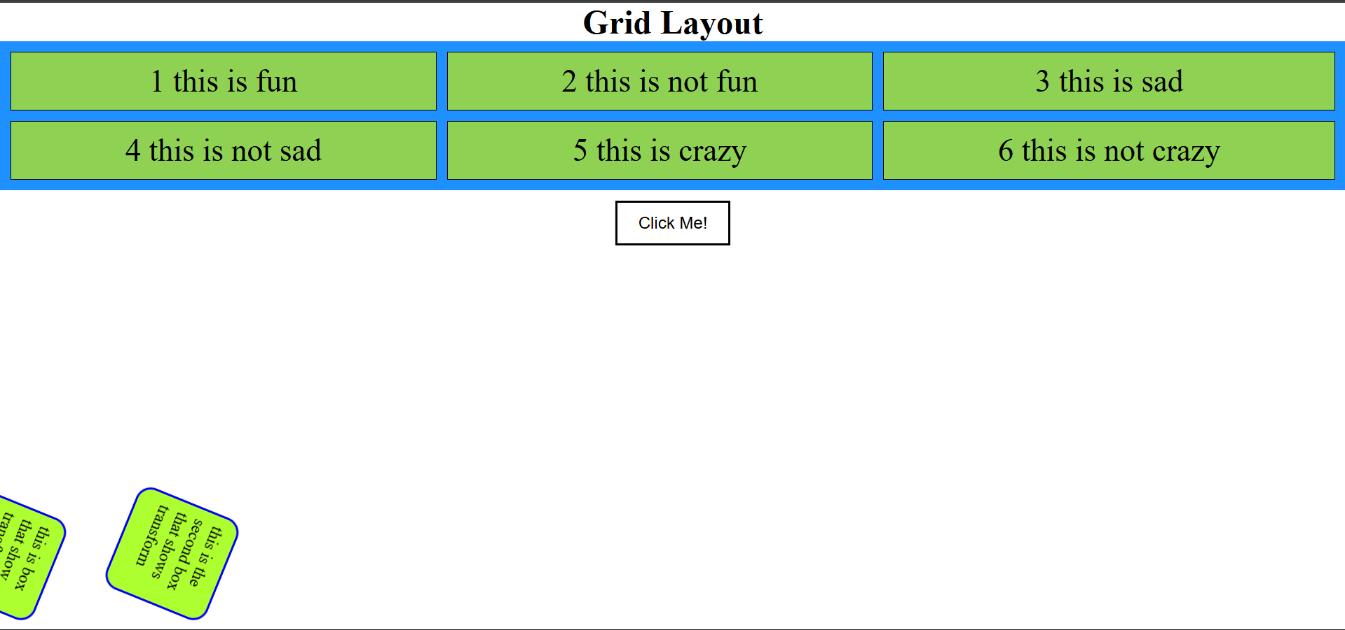

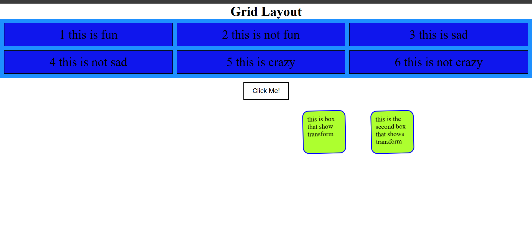

Here is the code:
<!DOCTYPE html>
<html>
<head>
<meta charset="UTF-8">
<title>Lab 3 - Grid Layout</title>
<link rel="stylesheet" href="lab3.css">
</head>
<body>

<h1>Grid Layout</h1>

<div class="container">
<div>1 this is fun </div>
<div>2 this is not fun</div>
<div>3 this is sad</div>
<div>4 this is not sad</div>
<div>5 this is crazy</div>
<div>6 this is not crazy</div>
</div>
<button class="click">
Click Me!
</button>
<section>
<div class="box box1">
<div>this is box that show transform</div>
</div>
<div class="box box2">
<div>this is the second box that shows transform</div>
</div>
</section>

</body>
</html>

*{
padding: 0;
margin: 0;
}
.container {
display: grid;
grid-template-columns: auto auto auto;
background-color: dodgerblue;
padding: 10px;
gap: 10px;
}
h1{
text-align: center;
}
.container div {
background-color: #f1f1f1;
border: 1px solid black;
padding: 10px;
font-size: 30px;
text-align: center;

background-color: blue;
animation-name: myAnimation;
animation-duration: 10s;
animation-iteration-count: infinite;}

@keyframes myAnimation {
from {background-color:greenyellow;}
to {background-color:blue;}
}
button:hover {
background-color: green;
color: white;
cursor: pointer;
}
button {
background-color: white;
border: 2px solid black;
padding: 10px 20px;
font-size: 16px;
display: flex;
justify-content: center;
align-items: center;
margin: 10px auto;
}
section{
display: flex;
}
.box {
animation-name: rotateAnimation;
animation-duration: 7s;
animation-iteration-count: infinite;

width: 80px;
height: 80px;
background-color: greenyellow;
transform: rotate(30deg);
padding: 10px;
border-radius: 15px;
border-color: blue;
border-style: solid;
border-width: 2px;
margin: 30px ;
}
.box:hover{
background-color: blue;
}
@keyframes rotateAnimation {
from {transform: rotate(0deg) translateX(0);}
to {transform: rotate(360deg) translateX(700px);}
}

